STUDENT SUMMER INTERNSHIP CONFERENCE ABSTRACT EXAMPLE – TEMPLATE

V. Surname¹, V. Surname²

¹ Kaunas Regional University (student’s home institution)
² Vilnius Institute (supervisor – research host institution)

The length of the abstract should not exceed 2 pages. The title of the abstract must be written in uppercase, bold, 16 pt Times New Roman font. The surnames of the student(s) and supervisor(s) must be written in 14 pt Times New Roman font. The surname of the student who participated in the project must be listed first and underlined. Numbers next to the surnames indicate the institutions of the student and the research supervisor. If the supervisor and the student are from the same institution, only one institution should be indicated, even if they belong to different faculties. If the research was carried out at a university institute, both the university and institute names must be indicated.
If graphs, photographs, schemes, etc. are used in the text, they must be numbered – the number and related information should be indicated below the figure. Figures up to 2 MB must be embedded in the text in graphical format. If copying a graph from Excel or another program, choose a copy/paste option that transfers only graphical information, for example: Copy → Paste Special → Picture.

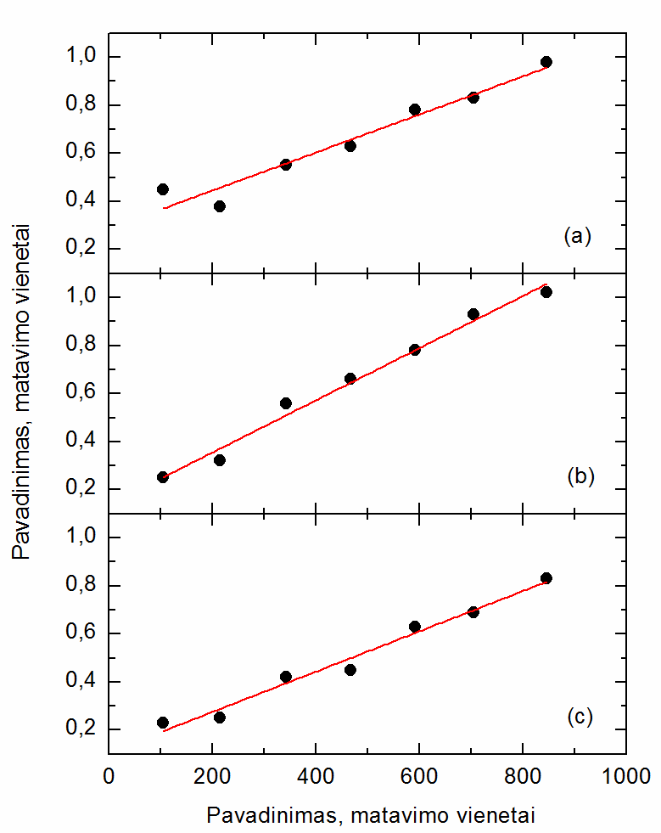
Fig. 1. Figure information in the abstract should be written in 11 pt Times New Roman font, single line spacing.

Tables may also be used in the abstract and must be numbered as well.
If formulas are included in the abstract, they should be inserted as images and numbered separately.
Cited references in the text should be indicated by numbers in square brackets [1] or [1, 2], etc., and listed at the end of the abstract. The reference list must be titled and written in 12 pt Times New Roman font. The reference list should be formatted as shown below.

The abstract must be saved as an MS Word file, with the file name indicating the student’s name, surname, and field of science (N – natural sciences, T – technology, M – medical and health sciences, A – agricultural sciences, H – humanities, S – social sciences, C – performing and screen arts, V – visual arts), e.g., Name Surname_N.

References
[1] Surname, Initial., Surname, Initial. Journal title, year, volume, pages from–to.
[2] Surname, Initial. Book title. Publisher, City, Year. Total number of pages.

